|  |
| --- |
| Rochester INstitute of technology |
| Android Devices as USB Hosts |
| RFID Project |
|  |
| **Saravana Kumar** |
| **7/17/2012** |

|  |
| --- |
| Making Android device as USB Host and receive data from a wireless sensor data receiver. |

ss

**Introduction:**

USB devices can be used as accessory device in Android from its version 3.1 and 2.3.4. Android provides connectivity by two types modes: USB accessory and USB host. In USB accessory mode, the external USB hardware act as the USB hosts. Examples of accessories might include robotics controllers; docking stations; diagnostic and musical equipment; kiosks; card readers; and much more. In USB host mode, the Android-powered device acts as the host. Examples of devices include digital cameras, keyboards, mice, and game controllers (Android, 2012). USB host mode could be used to connect wireless receiver device.

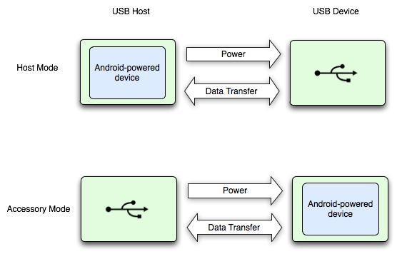

**USB Host Mode:**

Android-powered device in USB host mode acts as the USB host, powers the bus, and enumerates connected USB devices. USB host mode is supported in Android 3.1(API level 12) and higher. Multiple USB devices can be connected to a single Android device. Android provides various API classes to communicate with the devices. The USB host APIs are in “android.hardware.usb” package.

Communication between devices could synchronous and asynchronous. For asynchronous connection permission has to be got from the USB device using UsbRequest. Various classes and its uses are defined in the below table.

|  |  |
| --- | --- |
| Class | Description |
| [**UsbManager**](http://developer.android.com/reference/android/hardware/usb/UsbManager.html) | Allows you to enumerate and communicate with connected USB devices. |
| [**UsbDevice**](http://developer.android.com/reference/android/hardware/usb/UsbDevice.html) | Represents a connected USB device and contains methods to access its identifying information, interfaces, and endpoints. |
| [**UsbInterface**](http://developer.android.com/reference/android/hardware/usb/UsbInterface.html) | Represents an interface of a USB device, which defines a set of functionality for the device. A device can have one or more interfaces on which to communicate on. |
| [**UsbEndpoint**](http://developer.android.com/reference/android/hardware/usb/UsbEndpoint.html) | Represents an interface endpoint, which is a communication channel for this interface. An interface can have one or more endpoints, and usually has input and output endpoints for two-way communication with the device. |
| [**UsbDeviceConnection**](http://developer.android.com/reference/android/hardware/usb/UsbDeviceConnection.html) | Represents a connection to the device, which transfers data on endpoints. This class allows you to send data back and forth sychronously or asynchronously. |
| [**UsbRequest**](http://developer.android.com/reference/android/hardware/usb/UsbRequest.html) | Represents an asynchronous request to communicate with a device through a [**UsbDeviceConnection**](http://developer.android.com/reference/android/hardware/usb/UsbDeviceConnection.html). |
| [**UsbConstants**](http://developer.android.com/reference/android/hardware/usb/UsbConstants.html) | Defines USB constants that correspond to definitions in linux/usb/ch9.h of the Linux kernel. |

**USB Host Mode Sample Code:**

Host mode details and the walkthrough to make communication could be referenced from the Android developer site <http://developer.android.com/guide/topics/connectivity/usb/host.html>.

Sample Projects: <http://developer.android.com/tools/samples/index.html>

**Android Development Kit:**

To work with the development of USB host mode of Android device we need Android Development kit to be installed along normal Android Development environment. Find the below URL to do the setup<http://developer.android.com/tools/adk/adk2.html>**.**

**Device Recommendation:**

**Nexus-s:**

<http://www.android.com/devices/detail/nexus-s>

**Galaxy Tablet:**

<http://www.samsung.com/us/mobile/galaxy-tab>

If Galaxy we can use below USB adapter.

<http://www.samsung.com/us/mobile/galaxy-tab-accessories/EPL-1PL0BEGSTA>

**Nexus 7 Tablet:**

<http://www.google.com/nexus/#/7>

For other devices can buy adapter at amazon

<http://www.amazon.com/b/ref=nb_sb_noss?url=node%3D13983791&field-keywords=usb+to+nexus&rh=n%3A172282%2Cn%3A%21493964%2Cn%3A541966%2Cn%3A172504%2Cn%3A490499011%2Cn%3A13983791%2Ck%3Ausb+to+nexus>

**Challenges we will face:**

* USB wireless receiver compatibility with Android device.
* USB wireless receiver’s data format and reading it with Android device.

**References:**

1. Android, 2012 <http://developer.android.com/develop/index.html>.
2. Android ADK, 2012 <http://developer.android.com/tools/adk/adk2.html>